Data is duplicated bec when I logged in as admin and added a course and department , that addition was not conveyed when I logged in as course moderator so I had to create the department and courses again

Here when I logged in as admin I can see what admin added and what cm added which are same

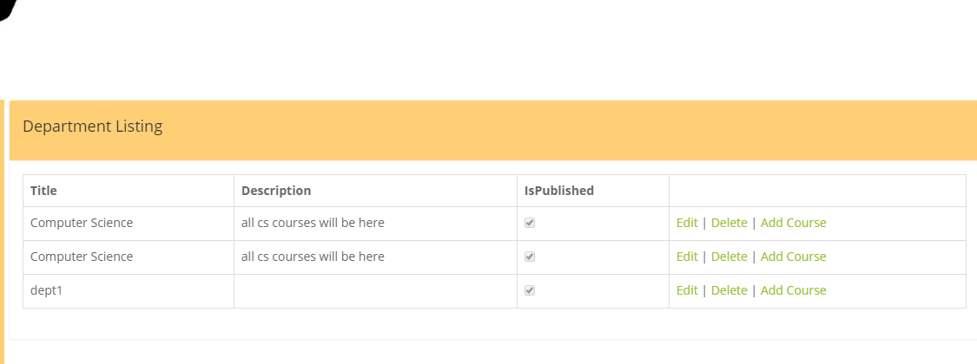

Also here I was logged in as admin

So we have to solve this as u see either when admin creates a course he has to link it with a course moderator, but the departments has to be conveyed in course moderator

Or we can make admin only manage the courses and departments and do not add..

I don’t know but I guess admin also has to add the courses and departments and ADMIN MUST BE ABLE TO DELTE any thing, in users admin CAN NOT dele a user so if its hard pls make admin at least disable a user or mark as deleted only so it wont be appears in website.

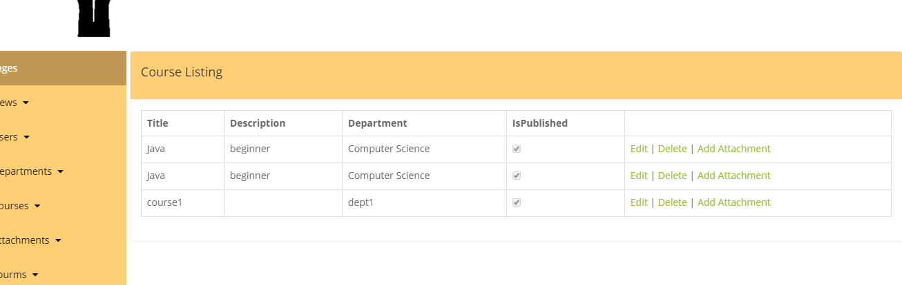

Now when I upload an attachment why does it focus on image only?? Also PLS make sure that attachment are uploaded bec it des sometimes and others no

(mazhar: Actually this happens because when we select upload attachment, you immediately upload the file and then once done we will click on Create, so if attachment is large, and client is clicking on Create before attachment upload completed it gives error.) so make Create disable until file uploaded successfully and View File appears so then we can click on Creare).

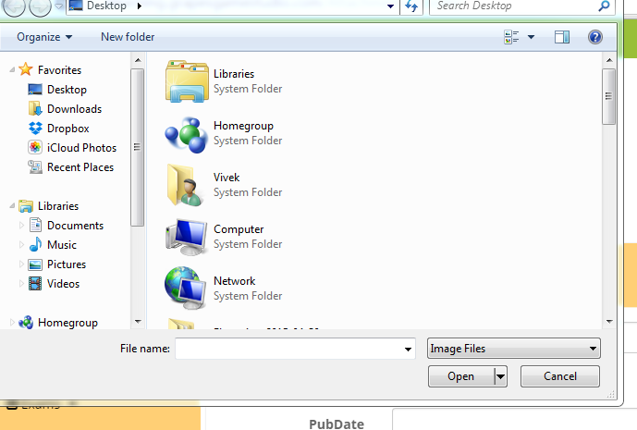

When I logged in as student the duplicate info is conveyed here so student can see same department names….

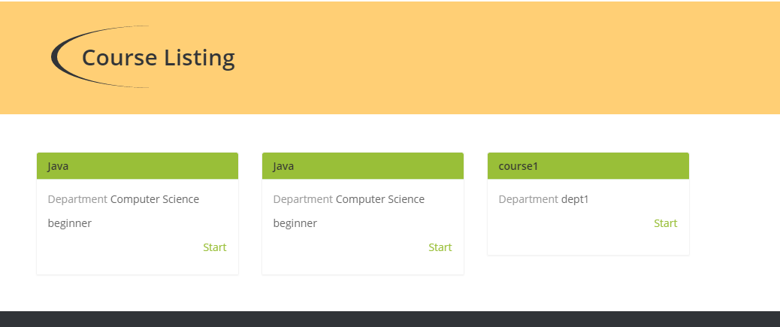

When I tried to download the attachment I get this error pls see

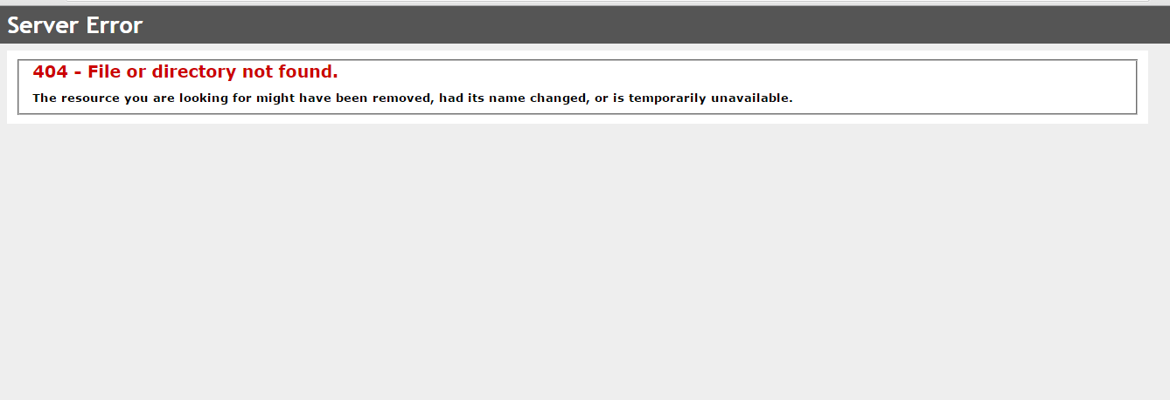

When creating the questions as course moderator the correct answer must be a drop down list with only the four options

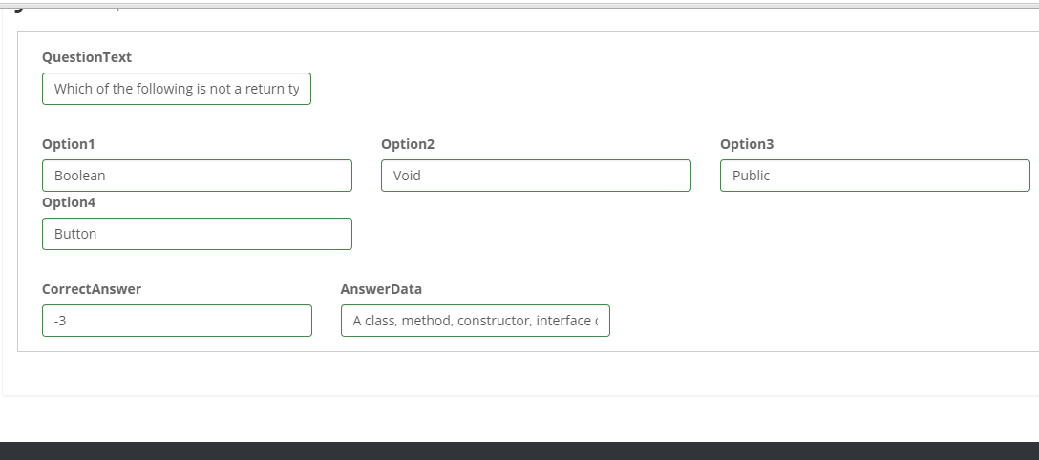

Now when I submit the question I need to see that I answered correct and instead of 3 in green we with “correct” and the correct option to be displayed the option I chose.

and instead of red 4 we will have “wrong” and we have to view the correct answer then correct answer data now we have 4 in red then correct answer data but we have to view the correct answer as well

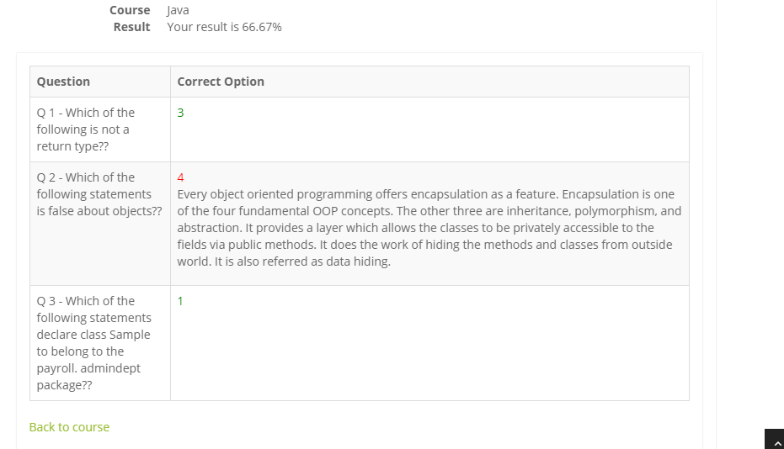

Also I am logged out of the session and I have to re log in?? and please the spelling mistakes in views course not cours

Please replace cours in whole solution with Course.

